任务来啦！！！！！！

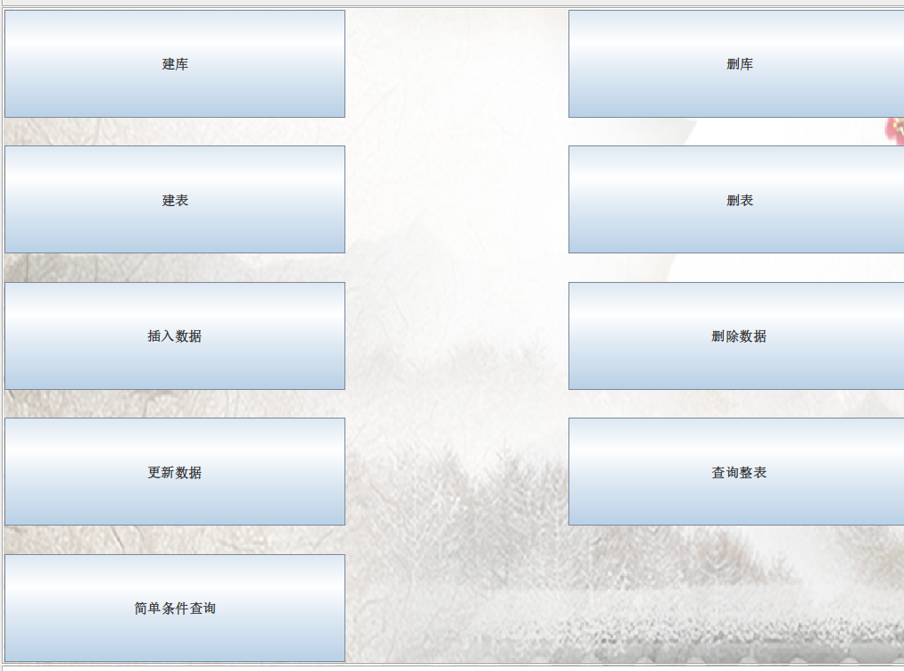11个sql语句：

* show databases;
* use dbName; show tables;
* create database dbName;
* drop database dbName;
* use dbName;

create table tableName (

columnName1 columnType1,

columnName2 columnType2,

columnName3 columnType3, (后面的逗号可加可不加，都要考虑进来)

)

* use dbName;

drop table tableName;

* use dbName;

insert into tableName(columnName1, columnName2……) values(value1, value2……);

* use dbName;

delete from tableName where columnName=value;

* use dbName;

update tableName set toName=toValue where fromName=fromValue;

* use dbName;

select \* from table Name;

* use dbName;

select \* from table Name where columnName=columnValue;